组合理论与算法研讨会
会议手册

2023年4月21日-24日
中国科学院数学与系统科学研究院
数学机械化重点实验室，北京

会议信息
时间：2023年4月21日-24日 （21日报到，地点数学院南楼204）
地点：北京中关村东路55号中国科学院数学院南楼204会议室

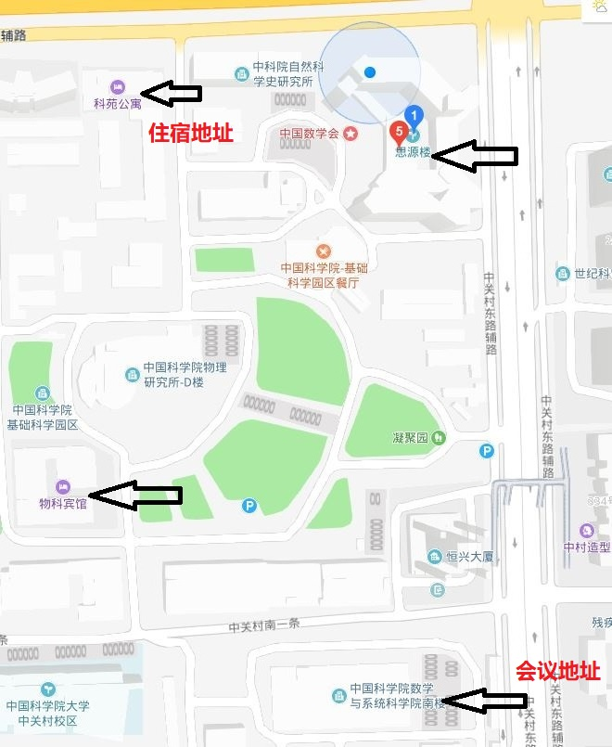

会议日程
会议报到：2023年4月21日下午2点-6点，南楼204
2023年4月22日周六学术报告（南楼204会议室）
时间 | 日程 | 演讲人
8:20-8:30 | 签到
8:30-8:40 | 开幕
8:40-8:50 | 特邀学者讲话 | 王军
8:50-9:50 | 置换与加法组合 I | 孙智伟
9:50-10:20 | 合影与茶歇
10:20-10:50 | 組合、图论學在物理、化學、統計上的應用 | 叶永南
10:50-11:20 | A multiple q-translation formula | 刘治国
11:20-11:50 | Abel引理与q-级数变换 | 马欣荣
11:50-12:20 | 非交换基本超几何级数导引 | 张之正
12:30-13:30 | 午餐（物科宾馆自助）
14:00-15:00 | Analytic Aspects of Combinatorial Sequences I | 王毅
15:00-16:00 | Analytic Aspects of Combinatorial Sequences II | 王毅
16:00-16:20 | 茶歇
16:20-16:50 | Kazhdan-Lusztig polynomials of complete graphs | 杨立波
16:50-17:20 | The stability of multivariate polynomial sequences | 刘丽
17:20-17:50 | Ehrhart Theory on Lattice Path Matroids | 范久瑜
18：00-20：00 | 晚宴（物科宾馆）

2023年4月23日周日（南楼204会议室）
时间 | 日程 | 演讲人
8:30-9:30 | Analytic Aspects of Combinatorial Sequences III | 王毅
9:30-10:30 | Analytic Aspects of Combinatorial Sequences IV | 王毅
10:30-10:50 | 茶歇
10:50-11:20 | Further Extensions of Haglund-Remmel-Wilson Identity | 严慧芳
11:20-11:50 | On lattice paths and the Thue-Morse sequence | 傅士硕
12:00-13:30 | 午餐（物科宾馆自助）
14:00-15:00 | 置换与加法组合 II | 孙智伟
15:00-16:00 | 置换与加法组合 III | 孙智伟
16:00-16:20 | 茶歇
16:20-16:50 | 完全对称多项式零点的新下界 | 张俊
16:50-17:20 | Further $q$-supercongruences from a transformation of Rahman | 郭军伟
17:20-17:50 | On a conjecture of Tokushige for cross-t-intersecting families | 张华军
18：00-20：00 | 晚餐（物科宾馆）

2023年4月24日周一（南楼204会议室）
时间 | 日程 | 演讲人
8:30-9:30 | 置换与加法组合 IV | 孙智伟
9:30-9:50 | 茶歇
9:50-10:20 | Modularity of Nahm Sums for the Tadpole Diagram | 王六权
10:20-10:50 | Generalized q-partial differential equations for q-3D hypergeometric polynomials and some applications | 曹健
10:50-11:20 | Symmetries in parking functions, Dyck paths and trees | 林志聪
11:30-14:00 | 午餐 (物科宾馆)
14:00-17:00 | 自由讨论

报告信息

题目1：置换与加法组合
报告人：孙智伟 教授（南京大学）
摘要： 与Abel群加法结构有关的加法组合是组合和数论的交叉领域，国际上这方面的研究十分活跃。本课程讨论有关的置换与和集问题，介绍这方面的已有结果与研究方法， 还将提及一些未解决问题。

题目2：組合、图论學在物理、化學、統計上的應用
报告人：叶永南 教授（温州大学）
摘要： 在這個演講裏。我將用淺顯的語言簡單介紹過去我用組合、圖論在物理、化學、統計等跨學科領域的一些應用。

题目3：A multiple q-translation formula
报告人：刘治国 教授（华东师范大学）
摘要： In this talk, we shall introduce a multiple q-exponential differential operational identity for the analytic functions in several variables, which can be regarded as a multiple q-translation formula. This multiple q-translation formula is a fundamental result and play a pivotal role in q-mathematics. Using this formula, we can easily recover many classical conclusions in q-mathematics and derive some new q-formulas.

题目4：Abel引理与q-级数变换
报告人：马欣荣 教授（苏州大学）
摘要： This talk is about three new and general transformations with sixteen parameters and bases via Abel's lemma on summation by parts. As their applications, we will exhibit some new transformations of basic hypergeometric series. Among include some new results of Gasper and Rahman's quadratic,cubic, and quartic transformations. Furthermore, we put forward the so-called $\left(R,S\right)$-type transformation with arbitrary degree to unify such multibasic transformations. Some special $\left(R,S\right)$-type transformations are presented.

题目5：非交换基本超几何级数导引
报告人： 张之正 教授（洛阳师范学院）
摘要：在本报告中，将从Gauss非交换二项式定理出发，介绍一般非交换基本超几何级数的基本概念及基本结果。

题目6：Analytic aspects of combinatorial sequences
报告人：王毅 教授（大连理工大学）
摘要： In this talk, we discuss some analytic properties of combinatorial sequences.

题目7：Kazhdan-Lusztig polynomials of complete graphs
报告人：杨立波 教授（南开大学）
摘要： Recently, Luis Ferroni and Matt Larson provide a combinatorial interpretation of Kazhdan–Lusztig polynomials of complete graphs. In particular, they confirm a conjecture of Elias, Proudfoot and Wakeﬁeld on the top coefficients of Kazhdan–Lusztig polynomials of complete graphs. In this talk we will show how to determine the top coefficients of inverse Kazhdan–Lusztig polynomials of complete graphs based on Ferroni and Larson's work.

题目8：A unified approach to multivariate polynomial sequences with real stability
报告人：刘丽 教授（曲阜师范大学）
摘要： We give some new sufficient conditions for a sequence of multivariate polynomials to be real stable. As applications, we obtain the real stability of many important multivariate polynomials, such as multivariate Eulerian polynomials, multivariate Bell polynomials and multivariate polynomials over Stirling permutations in a unified manner. And we also show some new results, such as the real stability of multivariate polynomials over Jacobi-Stirling permutations, and the proper position property of multivariate matching polynomials.

题目9：Ehrhart Theory on Lattice Path Matroids
报告人：范久瑜 副教授（四川大学）
摘要： We will give a survey of the Ehrhart theory of lattice path maroids and report our recent progress on this topic.

题目10：Further Extensions of Haglund-Remmel-Wilson Identity
报告人：严慧芳 教授（浙江师范大学）
摘要： MacMahon's equidistribution theorem states that the permutation statistics inversion number and major index are equidistributed. In 2015, Remmel and Wilson proved a conjectured identity of Haglund which is an extension of MacMahon's equidistribution theorem to ordered set partitions. Recently, Liu extended this identity to $k$-Stirling permutations and posed a conjecture concerning an ascent analogue of his extension. In this talk, we shall present a combinatorial proof of this conjecture. Furthermore, we derive an analogous result for another $maj-$ like statisticintroduced by Liu. This talk is based on joint work with Sha Ling, Lihong Yang and Robin D.P. Zhou.

题目11：On lattice paths and the Thue-Morse sequence
报告人：傅士硕 教授（重庆大学）
摘要： In answering a question of Berstel, Lauve, Reutenauer, and Saliola, we present a combinatorial argument basing on the symmetry of certain lattice paths to explain that the diagonal of certain bivariate rational function is congruent to the Thue-Morse series modulo 2.

题目12：完全对称多项式零点的新下界
报告人：张俊 教授（首都师范大学）
摘要： 在报告中，我们介绍最新的关于完全对称多项式零点个数的下界，该下界大大改进了已有的下界。该工作是与万大庆教授合作。

题目13： Further $q$-supercongruences from a transformation of Rahman
报告人：郭军伟 教授（淮阴师范学院）
摘要： Employing a quadratic transformation formula of Rahman and the method of `creative microscoping' (introduced by the author and Zudilin in 2019), we provide some new $q$-supercongruences for truncated basic hypergeometric series. In particular, we confirm two recent conjectures of Liu and Wang. We also propose some related conjectures on supercongruences and $q$-supercongruences.

题目14：On a conjecture of Tokushige for cross-t-intersecting families
报告人：张华军 教授（绍兴文理学院）
摘要： Two families of sets $A$ and$B$ are called cross-$t$-intersecting if $\left|A∩B\right|≥t$ for all $A∈A$, $B∈B$. In this talk, we will prove that for all $k≥t≥3$ and $n≥\left(t+1\right)\left(k-t+1\right)$, if $A,B⊆\left({\left[n\right] \atop k}\right)$ are cross-$t$-intersecting, then$\left|A\right|\left|B\right|≤{\left({n-t \atop k-t}\right)}^{2}$, equality holds if and only if $A$ and $B$ are the same maximum $t$-intersecting family of $\left({\left[n\right] \atop k}\right)$. This confirms a conjecture of Tokushige for $t≥3$.

题目15：Modularity of Nahm Sums for the Tadpole Diagram
报告人：王六权 教授（武汉大学）
摘要： We prove Rogers-Ramanujan type identities for the Nahm sums associated with the tadpole Cartan matrix of rank 3. These identities reveal the modularity of these sums, and thereby we confirm a conjecture of Calinescu, Milas and Penn in this case. We show that these Nahm sums together with some shifted sums can be combined into a vector-valued modular function on the full modular group. We also present some conjectures for a general rank. This talk is based on a joint work with Antun Milas.

题目16：Generalized q-partial differential equations for q-3D hypergeometric polynomials and some applications
报告人：曹健 教授（杭州师范大学）
摘要： In this talk, our investigation is focusing on $q$-analogue complex Hermite polynomials, which were motivated by Ismail and Zhang [Adv. Appl. Math. 80(2016), 70 --92.] and [Trans. Amer. Math. Soc. 369(2017), 6779 --6821.]. We give a new pair of $q$-3D Hermite polynomials and their corresponding $q$-partial differential equations. In addition, we generalize $\left(q,c\right)$-derivative operator of Zhang [Adv. Appl. Math. 121(2020), 102081, 23pp.] and $\left(q,λ\right)$-derivative operator of Yang [Ramanujan J. 2022, https://doi.org/10.1007/s11139-022-00617-w.] and give some applications. Moreover, we define the generalized homogeneous Rogers--Szegö polynomial and Stieltjes—Wigert polynomial involving two parameters in the binomial coefficient and find their corresponding $q$-partial differential equations. Finally, we define generalized $q$-3D Hermite polynomials with double binomial coefficients, find their corresponding $q$-partial differential equations and generalize some results of Ismail and Zhang.

题目17：Symmetries in parking functions, Dyck paths and trees
报告人：林志聪 教授（山东大学）
摘要： I will talk about some bijective proofs of several symmetries arising in Parking functions, Dyck paths and trees. This talk is based on my recent joint work with Yang Li and Tongyuan Zhao.

